Ideation Phase
Empathize & Discover

Date | 29 September 2026
Team ID | 6ab3d326a238dc999eb36ed1
Project Name | AI Weather Wise AP
Maximum Marks | 4 Marks

Empathy Map Canvas:
The AI WeatherWise API is designed for travellers and weather users who need simple and accurate weather information. Users want to check real-time weather conditions, understand weather data easily, and receive personalized suggestions for activities and clothing. However, raw weather information can be difficult to interpret and managing multiple locations can be inconvenient. AI WeatherWise addresses these needs by providing real-time weather data, favorite location management, easy-to-understand summaries, and AI-based personalized recommendations.
Example:
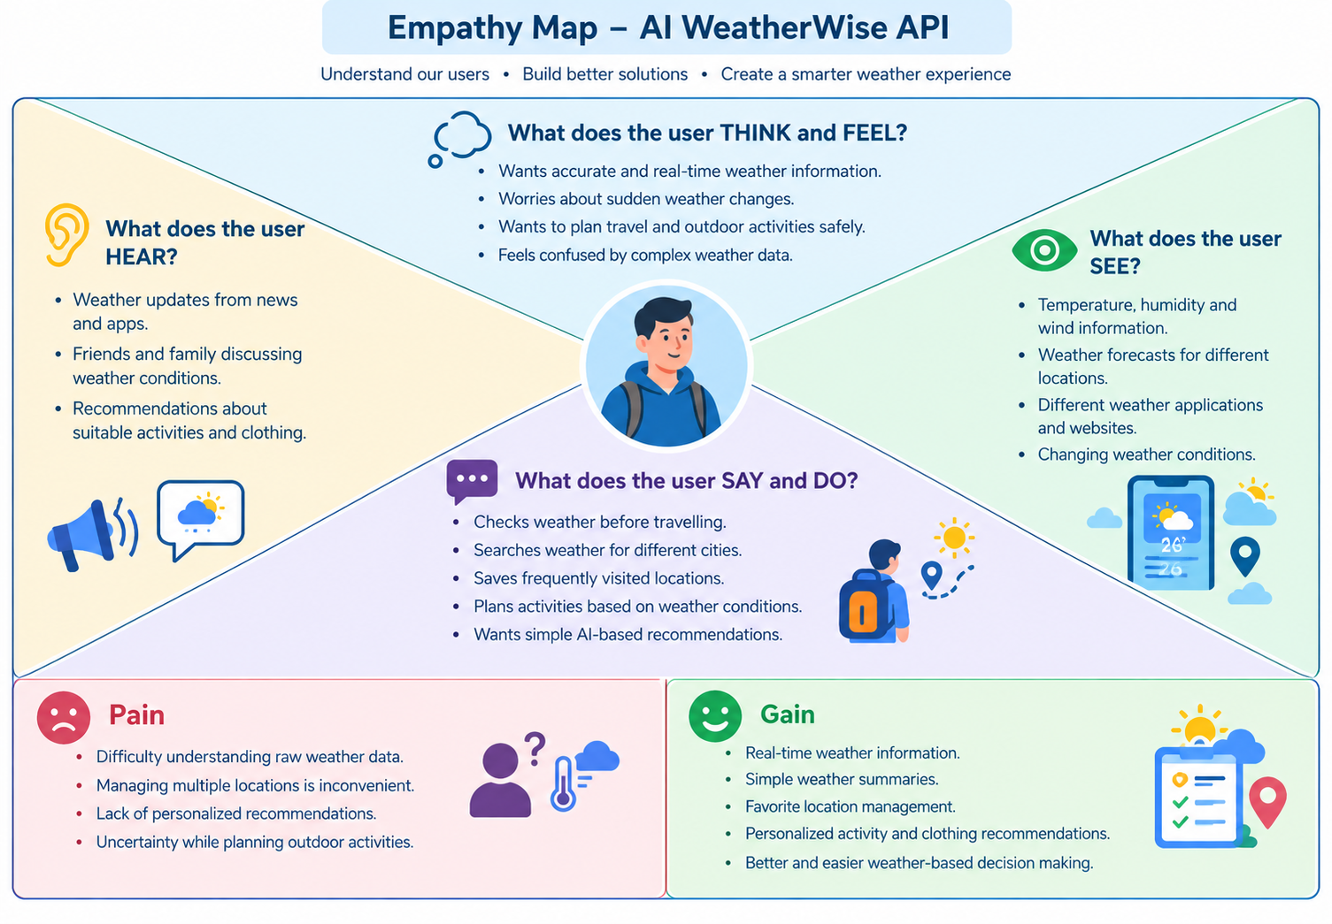

Reference: https://www.mural.co/templates/empathy-map-canvas

Example: Food Ordering & Delivery Application
